Partial Synonyms

🔹 What is Partial Synonyms
# Source: AI Source: Provided by: [Data Path: Persons Table -> ID Column: 1, Name_En Column: Motasem Essam] -> From: [Chatgpt (GPT-4-turbo)] on [7/30/2025]
Partial synonyms are words that share similar meanings but are not identical in all contexts, tone, usage, or connotation.

🧠 Definition:
# Source: AI Source: Provided by: [Data Path: Persons Table -> ID Column: 1, Name_En Column: Motasem Essam] -> From: [Chatgpt (GPT-4-turbo)] on [7/30/2025]
Partial synonyms are words that mean almost the same thing in some situations but cannot always be used interchangeably due to differences in register, nuance, collocation, or grammatical behavior.

📌 Key Features of Partial Synonyms:
# Source: AI Source: Provided by: [Data Path: Persons Table -> ID Column: 1, Name_En Column: Motasem Essam] -> From: [Chatgpt (GPT-4-turbo)] on [7/30/2025]
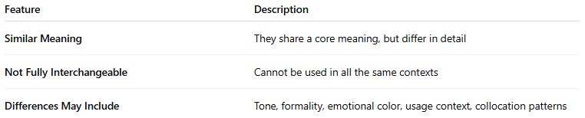
Feature | Description
Similar Meaning | They share a core meaning, but differ in detail
Not Fully Interchangeable | Cannot be used in all the same contexts
Differences May Include | Tone, formality, emotional color, usage context, collocation patterns

📚 Examples of Partial Synonyms:
# Source: AI Source: Provided by: [Data Path: Persons Table -> ID Column: 1, Name_En Column: Motasem Essam] -> From: [Chatgpt (GPT-4-turbo)] on [7/30/2025]
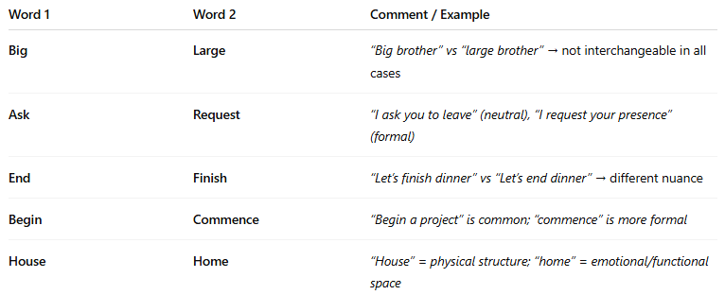
Word 1 | Word 2 | Comment / Example
Big | Large | “Big brother” vs “large brother” → not interchangeable in all cases
Ask | Request | “I ask you to leave” (neutral), “I request your presence” (formal)
End | Finish | “Let’s finish dinner” vs “Let’s end dinner” → different nuance
Begin | Commence | “Begin a project” is common; “commence” is more formal
House | Home | “House” = physical structure; “home” = emotional/functional space

🧠 Why They're Important:
# Source: AI Source: Provided by: [Data Path: Persons Table -> ID Column: 1, Name_En Column: Motasem Essam] -> From: [Chatgpt (GPT-4-turbo)] on [7/30/2025]
Understanding partial synonyms helps:
- Improve precision in word choice
- Avoid awkward or incorrect usage
- Enhance style and tone in writing and speaking

